Talks Module
Add as many tabs and talks as needed
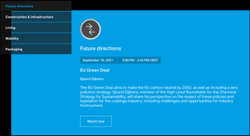 | Max. char. | English Content | Comment(s) / Feedback
Module Headline | 60
Tab 1 | 60
Talk 1
Headline | 25
Copy | 300
Date, Time & Time zone
Location
Speakers (name, title, jobrole, company)
MediaHub ID
192*192 px

Alt-Text
Link
Gated |  | [ ] Yes, [ ] No
Button label | 30
Talk 2
Headline | 25
Copy | 300
Date, Time & Time zone
Location
Speakers (name, title, jobrole, company)
MediaHub ID
192*192 px

Alt-Text
Link
Gated |  | [ ] Yes, [ ] No
Button label | 30
Tab 2 | 60
Talk 2
Headline | 25
Copy | 300
Date, Time & Time zone
Location
Speakers (name, title, jobrole, company)
MediaHub ID
192*192 px

Alt-Text
Link
Gated |  | [ ] Yes, [ ] No
Button label | 30

