Key Benefits (max. 5)
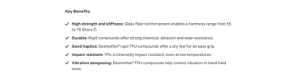 | Max. char. | English Content | Comment(s) / Feedback
Benefit 1 Title | 20 |  | For consistency of style, please use an adjective rather than a noun where possible. Please follow this with a colon. E.g.: “Flame retardant:”
Benefit 1 Text | 80 |  | Short description of benefit in consistent style
Benefit 2 Title | 20
Benefit 2 Text | 80
Benefit 3 Title | 20
Benefit 3 Text | 80
Benefit 4 Title | 20
Benefit 4 Text | 80
Benefit 5 Title | 20
Benefit 5 Text | 80

