Highlight module
Add as many slides as needed
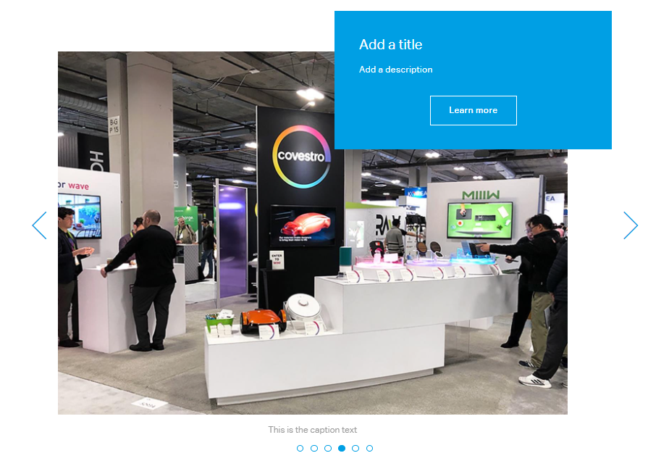 | Max.  char. | English Content | Comment(s) / Feedback
Component title | 60
Slide 1
MediaHub ID / Moving image id
Caption text | 100 |  | Caption to be shown beneath image
Alt-Text | 100 |  | Short description of image used if image can’t be displayed
Copyright |  |  | If copyright mention needed, please add it onto the image (for stage and content images) or refer in caption text (only for content images)
Title | 60
Description | 300
Link
Slide 2
MediaHub ID
Caption text | 100 |  | Caption to be shown beneath image
Alt-Text | 100 |  | Short description of image used if image can’t be displayed
Copyright |  |  | If copyright mention needed, please add it onto the image (for stage and content images) or refer in caption text (only for content images)
Title | 60
Description | 300
Link
Placement |  |  | Before a subline or in slider module

