Featured Products
Up to 6 related products that could be interesting to the customer reading this article

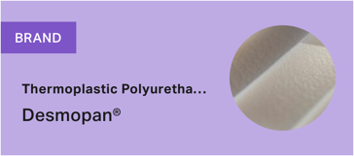 | Max. char. | English Content | Comment(s) / Feedback
Priority Region |  | [ ] EMLA  [ ] NAFTA  [ ] APAC | For non-global products
Product 1 |  |  | Name of highlight product  of brand
Product 2
Product 3
Product 4

