Featured Articles
Links to up to 6 related stories or case studies that could be interesting to the customer reading this article
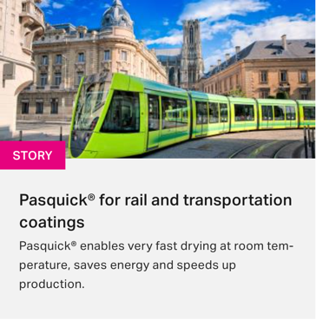 | Max. char. | English Content | Comment(s) / Feedback
Title | 40
Article 1
Article 2
Article 3
Article 4
Article 5
Article 6

