Benefit tiles (max. 3)
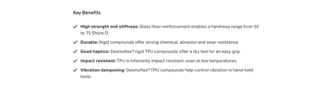 | Max. char. | English Content | Comment(s) / Feedback
Icon 1 |  |  | We can only use fixed set of icons: https://solutions.covestro.com/en/highlights/articles/cases/2019/all-modules/images-and-video/icons
Benefit 1 Title | 40 |  | For consistency of style, please use an adjective rather than a noun where possible. Please follow this with a colon. E.g.: “Flame retardant:”
Benefit 1 Text | 260 |  | Short description of benefit in consistent style
Icon 2
Benefit 2 Title | 40
Benefit 2 Text | 260
Icon 3
Benefit 3 Title | 40
Benefit 3 Text | 260

